PROJECT DAY 12 REPORT: EXPLOITATION CONCEPTS
Student Name: Urooj
Project Title: Understanding Exploit vs Vulnerability, PoC, Impact and Attack Chain

1. LAB SETUP:
Attacker Machine: Kali Linux
IP: 192.168.56.101
Target Machine: Metasploitable 2
IP: 192.168.56.102
Network Mode: Host-Only Adapter
Environment: Controlled Lab (Isolated, No Internet)

2. STEP 1: RECONNAISSANCE (Target Verification)
Objective: To verify if target is live and reachable.
Command Used:
ping 192.168.56.102

Result:
8 packets transmitted, 8 received, 0% packet loss
Conclusion: Target is live and responding.

[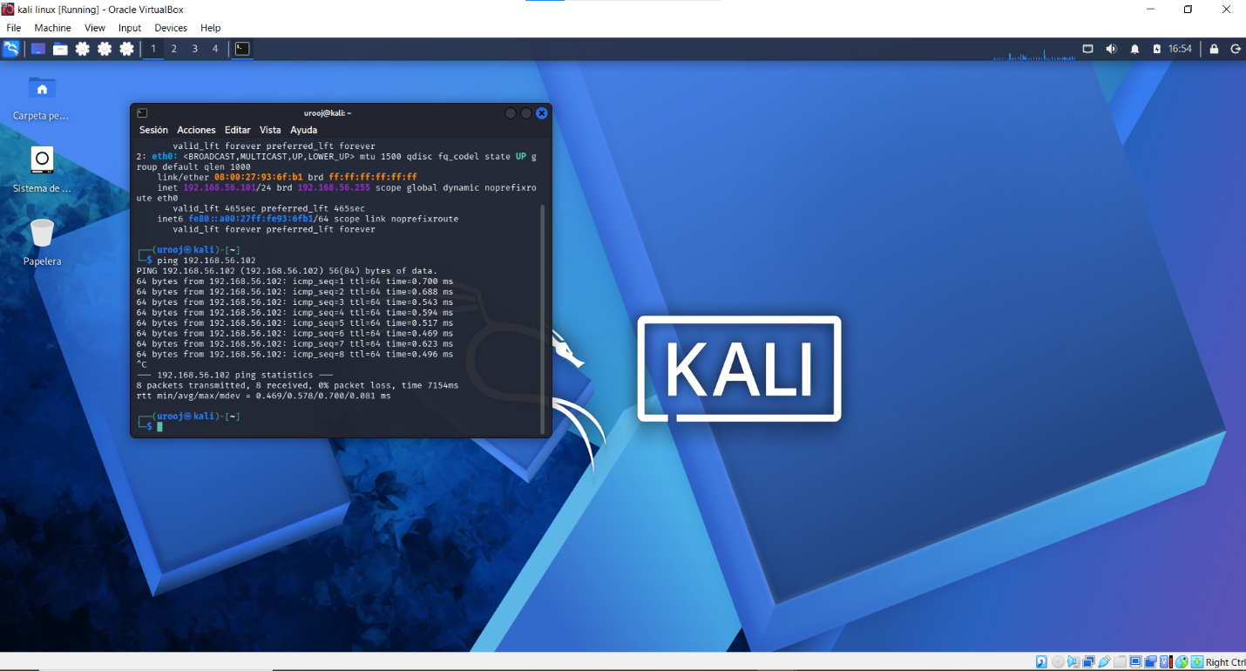 - Ping Result ]

3. STEP 2: VULNERABILITY SCANNING
Objective: To identify open ports and services.
Command Used:
nmap -sV 192.168.56.102

Result - Open Ports / Services Found:
21/tcp open ftp vsftpd 2.3.4
22/tcp open ssh OpenSSH 4.7p1
23/tcp open telnet Linux telnetd
25/tcp open smtp Postfix smtpd
80/tcp open http Apache httpd 2.2.8
139/tcp open netbios-ssn Samba smbd 3.X
445/tcp open netbios-ssn Samba smbd 3.X
3306/tcp open mysql MySQL 5.0.51a
5432/tcp open postgresql PostgreSQL 8.3

These open ports are considered as Vulnerabilities.

[ 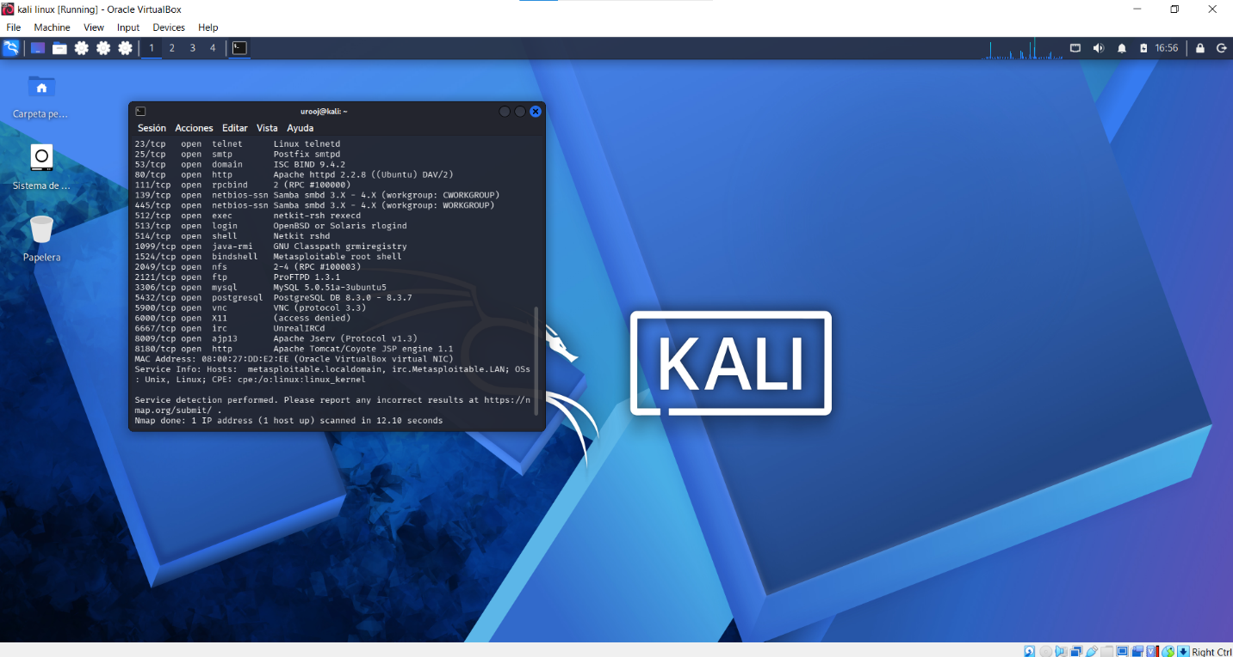- Nmap Result ]

4. EXPLOIT VS VULNERABILITY:
Vulnerability: A weakness or flaw in the system. Example: Open port 21 (FTP).
Exploit: A method or code used to take advantage of that vulnerability to gain unauthorized access.
In this lab, we only identified vulnerabilities. No exploit was executed.

5. PROOF OF CONCEPT (PoC):
PoC is evidence that proves vulnerability exists without causing harm.
Our PoC is the nmap scan screenshot showing multiple open and outdated services.
No data was accessed, modified, or deleted. This is for educational purpose only.

6. IMPACT ANALYSIS:
If this was a real production server, the Impact would be HIGH / CRITICAL.
- Confidentiality Loss: Attacker can steal files via FTP (21) and database via MySQL (3306).
- Integrity Loss: Attacker can deface website via HTTP (80).
- Availability Loss: Attacker can shutdown services via open telnet/ssh.
- Overall Risk: Data breach, financial loss, reputation damage.

7. ATTACK CHAIN:
1. Reconnaissance -> Verified target is live using ping.
2. Scanning -> Used nmap -sV to discover open ports and service versions.
3. Vulnerability Identification -> Listed open services as potential vulnerabilities.
4. PoC Creation -> Captured scan results as proof without exploitation.
5. Impact Assessment -> Analyzed what damage could occur if exploited.

8. CONCLUSION AND ETHICAL NOTE:
This entire activity was performed in a 100% controlled and legal lab environment.
Target Metasploitable 2 is intentionally vulnerable VM made for learning.
No real-world systems, networks, or websites were scanned or attacked.
The objective to understand core exploitation concepts was successfully achieved.

